Guided Capstone Step 6

Mason Voelbel

**Problem Statement:** How can Big Mountain Resort leverage their unique features to adjust value of ticket price in the next year? Big Mountain Resort’s current ticket pricing strategy focuses simply on the ticket price of its competitors. This strategy fails to consider the unique features that Big Mountain Resort has, and how those features can translate into more value for customers to allow for increased ticket revenue.

**Data Wrangling:** Data for this project was supplied from a single csv file which upon initial inspection had 330 rows and 27 columns, although in many of these columns there was at least one missing data observation. Through cleaning the data we dropped the fastEight column as it had over 50% missing values. With other columns we were able to supply missing values. Finally ending with cleaned dataframe containing 277 rows and only 25 columns.

**Exploratory Data Analysis:** Next came exploratory data analysis where we evaluated the data much more carefully to understand the relationship between variables and identify any quirks or outliers in the data. For the Big Mountain problem one interesting revelation was the heatmap created with seaborn. This allowed us to see the relationship between key features of a ski resort. Additionally we used PCA to evaluate how these features have an effect on ticket price. 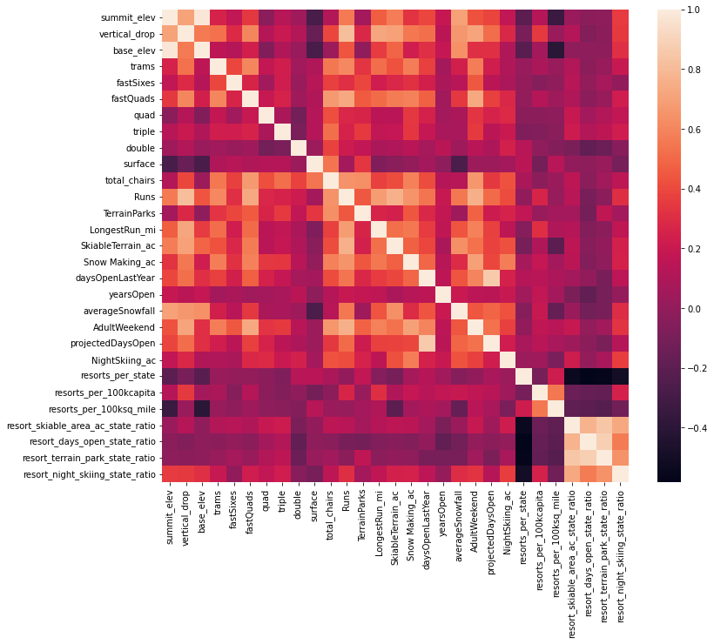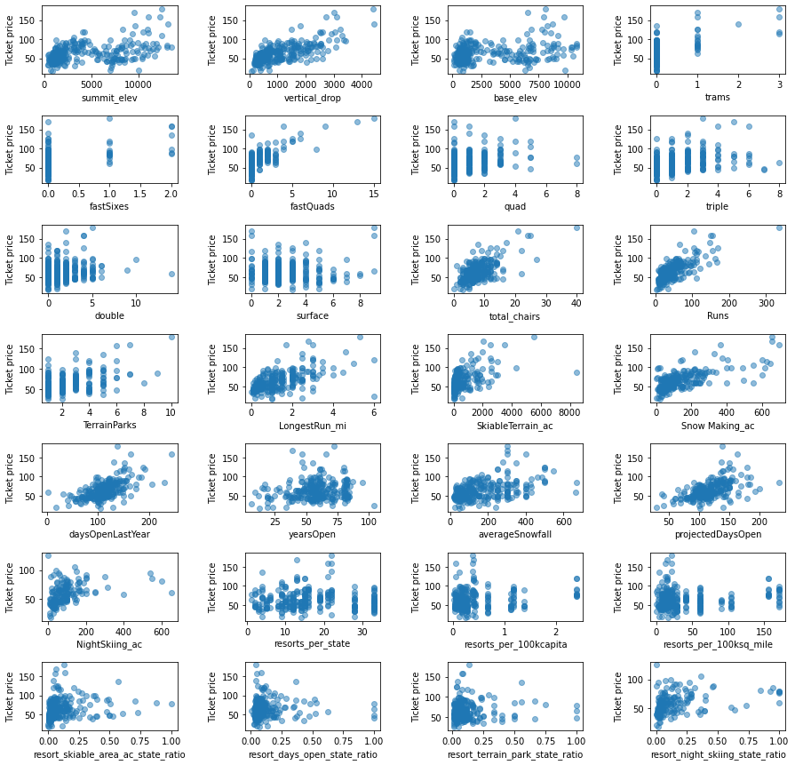

**Modeling:** Before beginning to actually model we first had to preprocess data which involved imputing missing data. Then we had to train the model and select the best model for the task. Initially we opted to use a linear regression model however after comparing this model with a random forest regression model we found the random forest model had a lower mean absolute error by almost $1 and elected to use this route instead. Finally we evaluated if the available data was sufficient by measuring cross validation scores as training set size changes.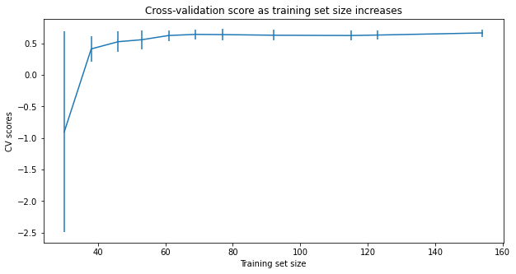

After selecting the best model came of the task of using it to solve the inital question. To do this we used some potential scenarios that Big Mountain Resort was considering to cut costs or increase revenue from ticket price. We modeled four scenarios and predicted how they would impact ticket price using our trained model. Of the considered scenarios, adding 1 additional run, 150ft of vertical drop, and one more chair lift seemed the best option. Our model predicts this scenario supports an increased ticket price of $1.99 which generates an additional ~$3500000 of revenue over the season.

**Conclusion:** Big Mountain Resort can definitely afford to raise ticket prices. Currently at $81 for an Adult, Big Mountain is undercharing relative to its value in the market. Price models initially supported a ticket increase up to $95 a ticket. When taking market contect into account however a more conservative approach of ticket price increase of $1.99 is more supported, especially when combined with the scenario mentioned above where Big Mountain Resort adds an additional run, chair lift and adds another 150ft to the vertical drop on the slopes. This model could be further improved by considering overall operating costs. By including costs we could also evaluate which future scenarios will maximize revenue while simultaneously minimizing cost increase.